**PROJECT-1**

**PROJECT TITLE**

**DEPLOYING AN PROJECT INTO DIFFERENT ENVIRONMENTS**

**THROUGH USING JENKINS PIPELINE**

**G. SHIVA KUMAR REDDY**

**Tomcat**

**Mail ID :gaddamsiva18@gmail.com**

**Batch No 115**

**Timing 9-10 AM**

Creating a pipeline in the Jenkins.

User writes declarative pipeline.

Creating AMI ‘s using single instance.

Deploy application into different environments (DEV_ENV, TEST_ENV,•  PRE_PROD_ENV, PROD_ENV).

Procedure of Job:

We need to take 4 servers using for tomcat web application need to install tomcat 9th version with all servers as well as to require changes in the each server commits and need change tomcat server.xml and we have to open Jenkins server deploy in the different environment.

**Architecture of Tomcat Jenkins Project:**

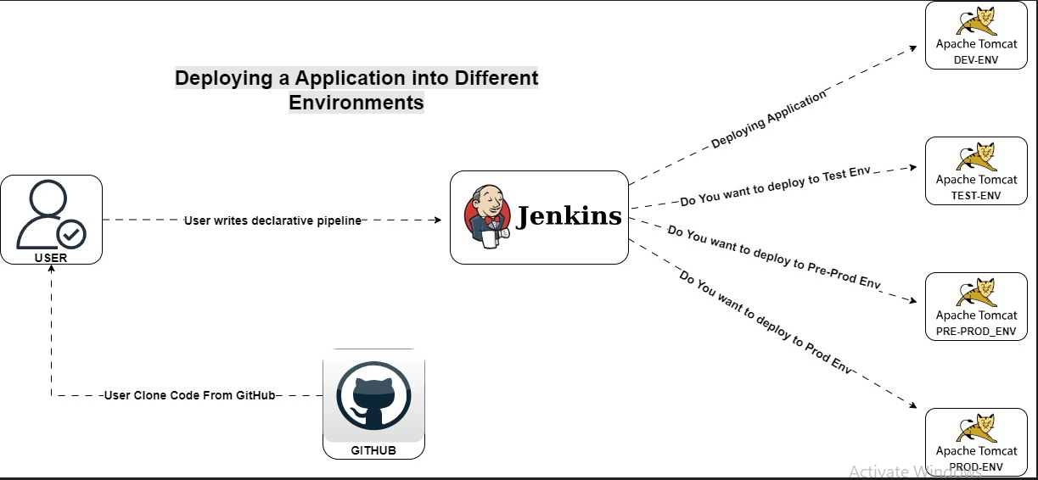

Open for 4 Tom cat servers

---------------------------------------------- **Jenkins** ----------------------------------------------

**Jenkins:** Jenkins is an open-source automation server. It helps automate the parts of software development related to building, testing, and deploying, facilitating continuous integration, and continuous delivery. It is a server-based system that runs in servlet containers such as Apache Tomcat. It is created using Java language, it executes the applications in Java language and also it can execute the all types of languages. To run Jenkins software, we need the Java software to be installed and maven software to be installed in the system.

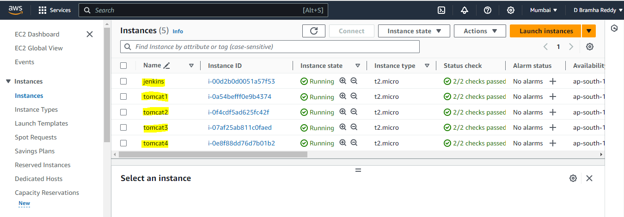

--------------------------------- **Installation of Jenkins and Tomcat** -------------------------- In AWS console open Terminal from the sever that created in the in AWS console. 1. Change user to root user using “Sudo -i”

2. Then update the system using “apt update -y”

3. After install Java jdk using command “apt install default-jdk -y”

4. Install Maven

5. Open the Jenkins webpage in the Google Search, open downloads and click ubuntu.

6. Then copy and paste given commands

sudo wget -O /usr/share/keyrings/jenkins-keyring.asc \

https://pkg.jenkins.io/debian-stable/jenkins.io-2023.key

7. Then add a Jenkins apt repository entry:

echo deb [signed-by=/usr/share/keyrings/jenkins-keyring.asc]

https://pkg.jenkins.io/debian-stable binary/ | sudo tee \

/etc/apt/sources.list.d/jenkins.list > /dev/null

8. Update your local package index, then finally install Jenkins:

sudo apt-get update

sudo apt-get install fontconfig openjdk-11-jre

sudo apt-get install jenkins

9. Check if we Java, Maven and Jenkins

Java --version

Maven --version

Jenkins –version

10. To install Tomcat use commands

https://downloads.apache.org/tomcat/tomcat-9/v9.0.83/bin/apache

tomcat-9.0.83.tar.gz.sha512

Install and Setup the Environment of Jenkins and Tomcat in the sever.

Open the Jenkins sever using the IP address and default port “8080”.

Create the Username and Password for the Jenkins. Open Jenkins dashboard. Open the Tomcat sever using the Ip address and default port “8080”

Open the Tomcat sever using preinstall username and password, it redirects to the interface

of the Tomcat.

To start the tomcat server

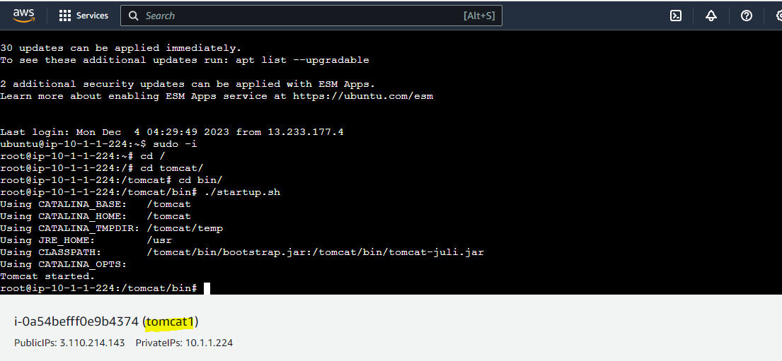

Next server

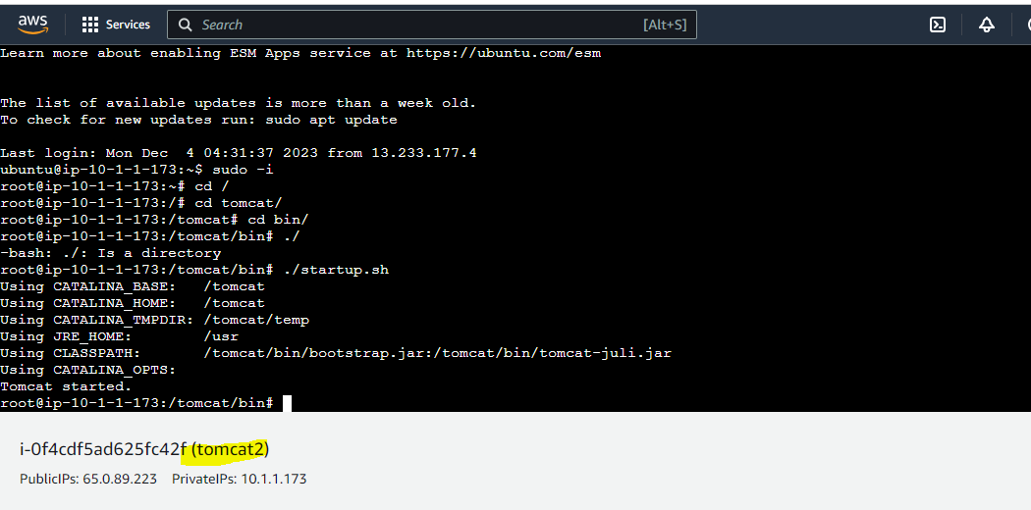

Next server

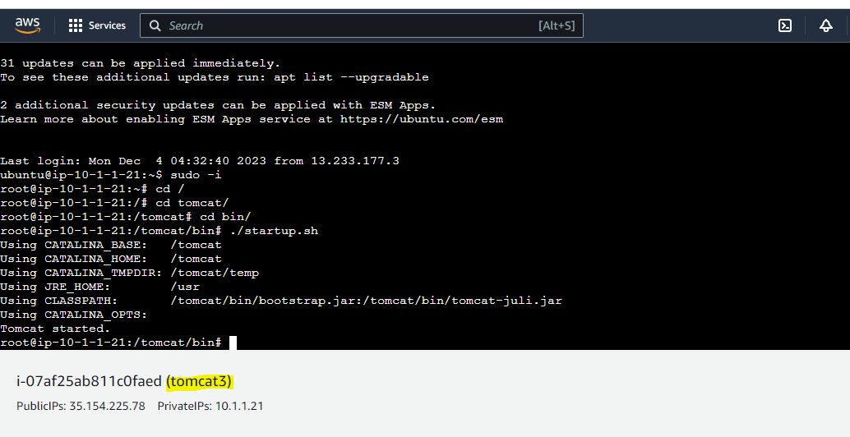

Next server

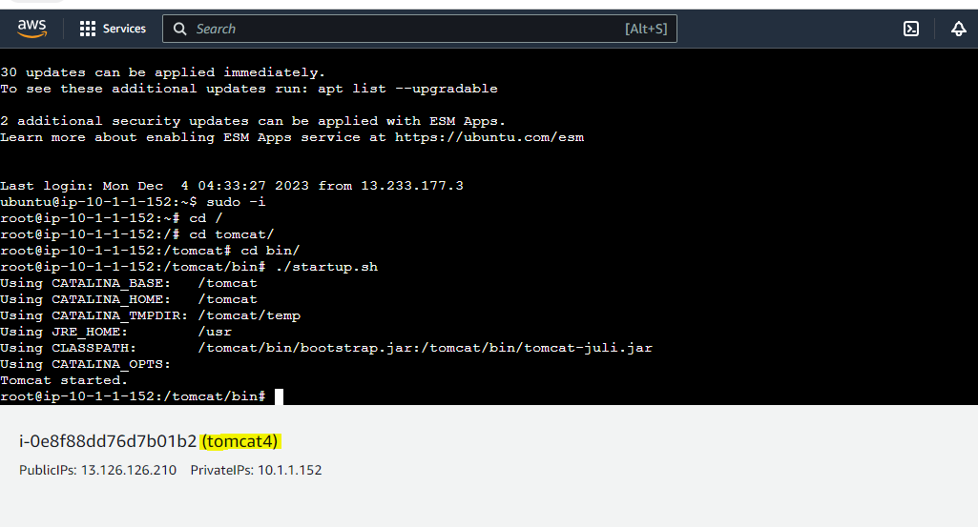

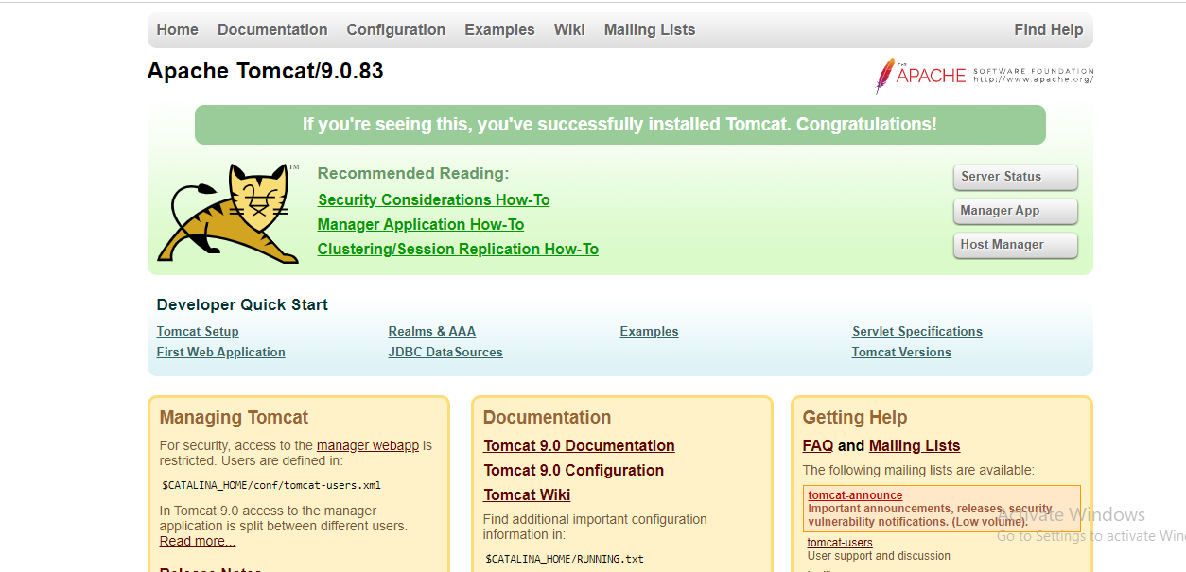

Here we need to go with Managers app here we which severs we need to deploy we have decided Then we need to open Jenkins we have to create a pipe line job.

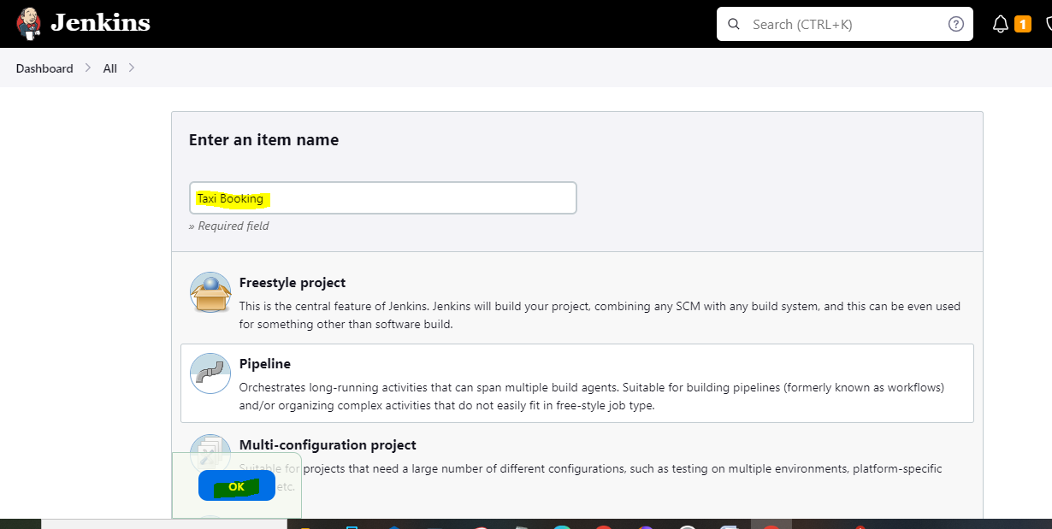

We need to use Tomcat deploy in the Jenkins

In that Tomcat web we need to changes then it will be open host manager

Steps:

1. Open tomcat server
2. Cd tomcat ---🡪ls
3. Go to web apps
4. Cd host manager ---🡪ls
5. Cd META INF-🡪ls
6. Vi context.xml come down here give commits
7. <!-- -->

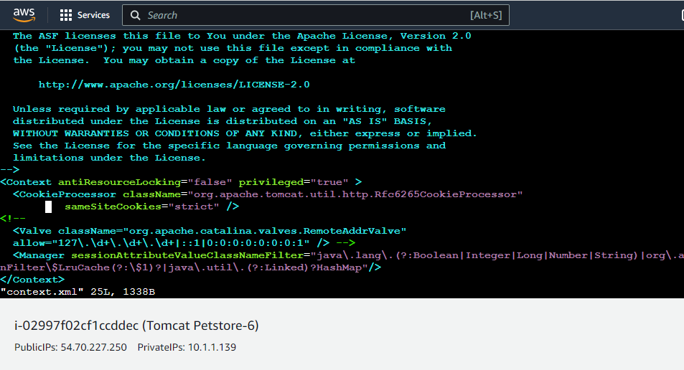

After that as same as do it commits manager



Then com back to root we have change config

Steps:

Cd tomcat

Cd conf------🡪ls

Vi tomcat-users.xml

Here we need to give tomcat password and user name through script

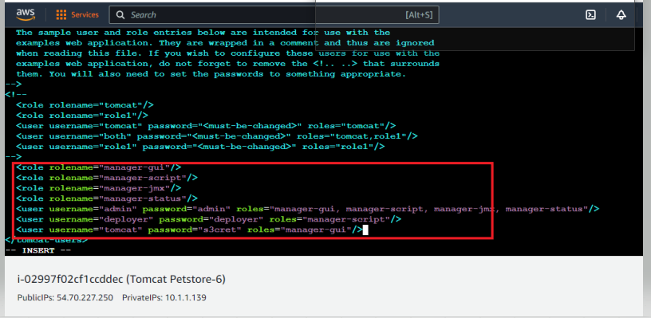

After that changes once we have stop and start the server then it will open

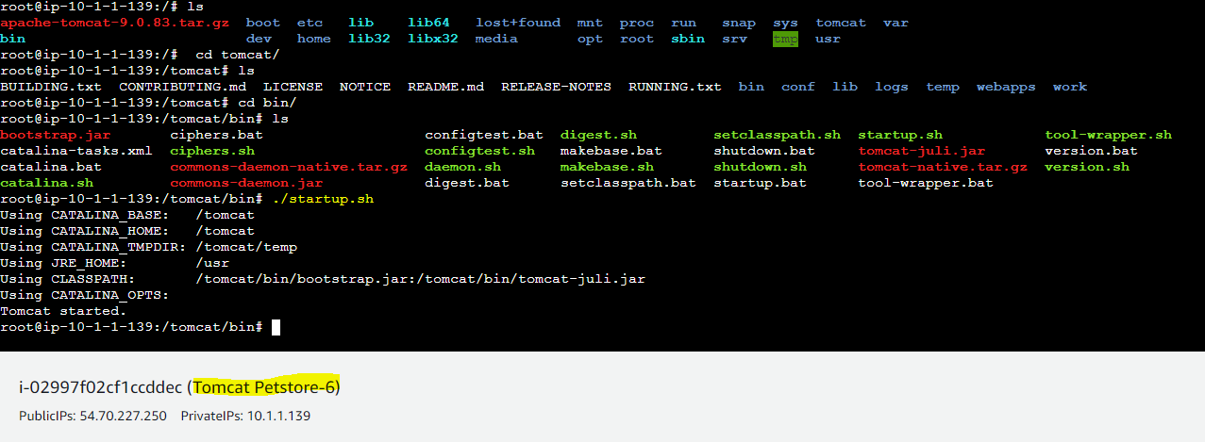

Now we have completed tomcat internal changes

Then we are go with Jenkins server to deploy the in to the tomcat web Taxi Booking application

So we need to create Jenkins new job with pipeline

Here to create a pipeline job for deploying purpose:



Now we have to write a script to deploy in the Different servers Dev, Preprod , Test,

Prod

**This is script of Project -1**

pipeline {

agent any

parameters {

choice (

choices: ['YES', 'NO'],

description: 'deploy the application ?',

name: 'DEV_DEPLOY'

)

choice (

choices: ['YES', 'NO'],

description: 'deploy the application ?',

name: 'TEST_DEPLOY'

)

choice (

choices: ['YES', 'NO'],

description: 'deploy the application ?',

name: 'PREPROD_DEPLOY'

)

choice (

choices: ['YES', 'NO'],

description: 'deploy the application ?',

name: 'PROD_DEPLOY'

)

}

stages{

stage('clone'){

steps{

git branch: 'dev', url: 'https://github.com/shiva97054/taxi-booking.git'

}

}

stage('install'){

steps{

sh 'mvn clean install'

}

}

stage('deploy to tomcat DEV'){

when{

expression{

params.DEV_DEPLOY =='YES'

}

}

steps{

deploy adapters: [tomcat9(credentialsId: 'jenkins.', path: '', url: 'http://65.0.103.245:8080/')], contextPath: 'Taxi Booking 115 batch', war: '**/*.war'

}

}

stage('deploy to tomcat test'){

when{

expression{

params.TEST_DEPLOY =='YES'

}

}

steps{

deploy adapters: [tomcat9(credentialsId: 'jenkins.', path: '', url: 'http://15.206.166.32:8080/')], contextPath: 'Taxi Booking 115 batch', war: '**/*.war'

}

}

stage('deploy to tomcat preprod'){

when{

expression{

params.PREPROD_DEPLOY =='YES'

}

}

steps{

deploy adapters: [tomcat9(credentialsId: 'jenkins.', path: '', url: 'http://3.110.170.163:8080/')], contextPath: 'Taxi Booking 115 batch', war: '**/*.war'

}

}

stage('deploy to prod'){

when{

expression{

params.PROD_DEPLOY =='YES'

}

}

steps{

deploy adapters: [tomcat9(credentialsId: 'jenkins.', path: '', url: 'http://13.235.94.60:8080/')], contextPath: 'Taxi Booking 115 batch', war: '**/*.war'

}

}

}

}

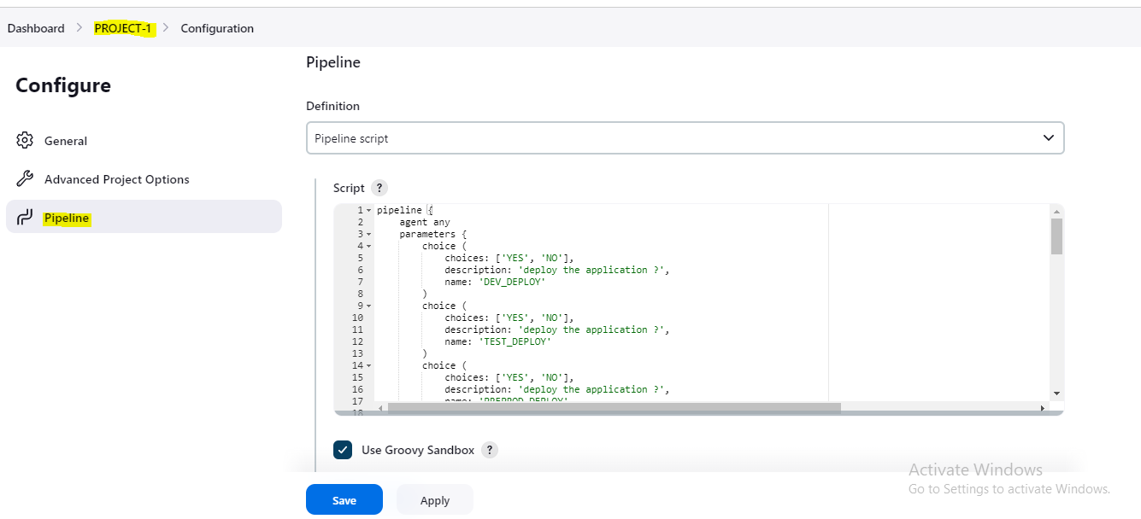

Apply and Save

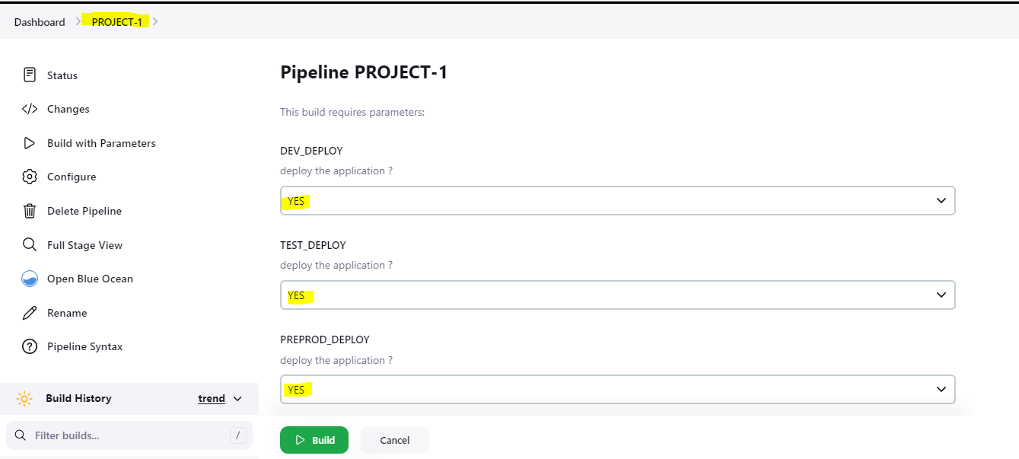

If we are given YES it will attempt if we are not given NO it is skipped

If YES:

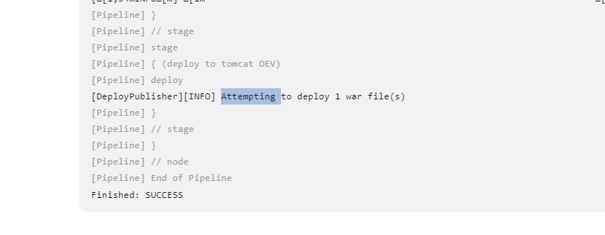

If NO:

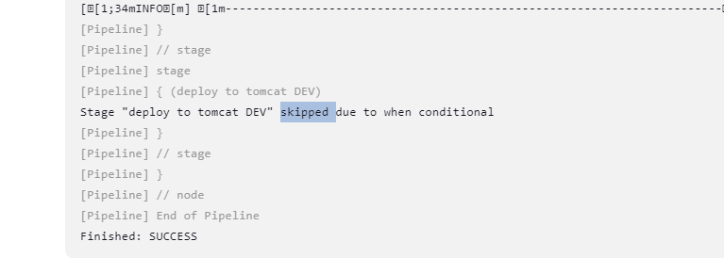

Here we have to observe which servers has deploy which servers not to deploy

This is the condition of this project

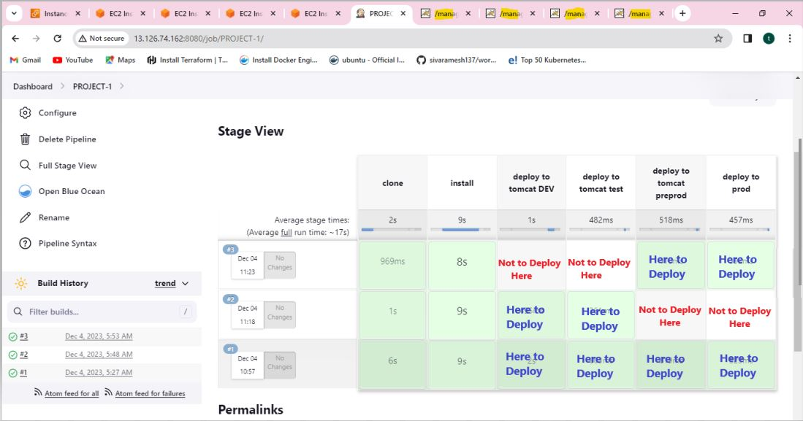

Then we have to verify in the tomcat each server

There is deploy or not Taxi Booking 115 Batch name

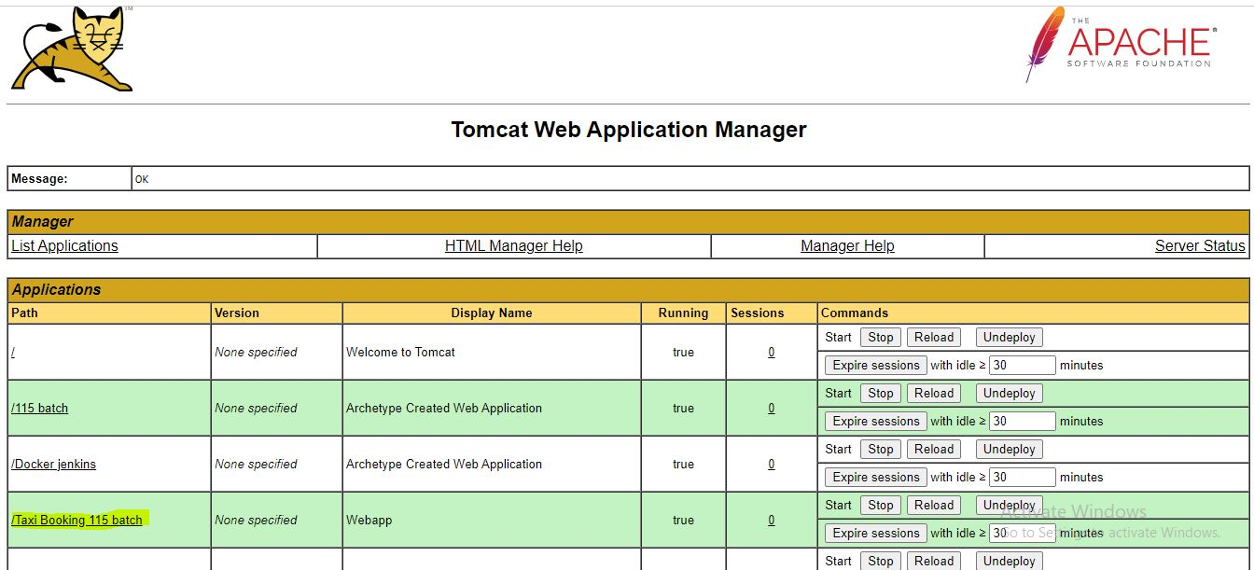

Next Server

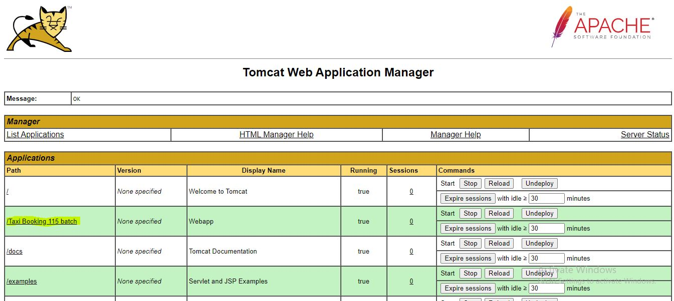

Then once we have to check once

Taxi Booking what is in the project click here It will be open

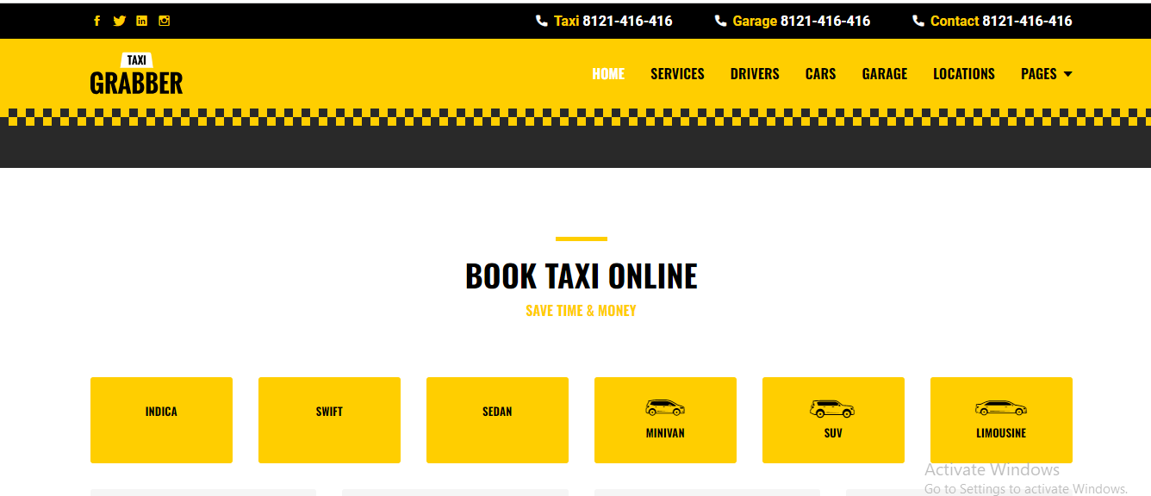

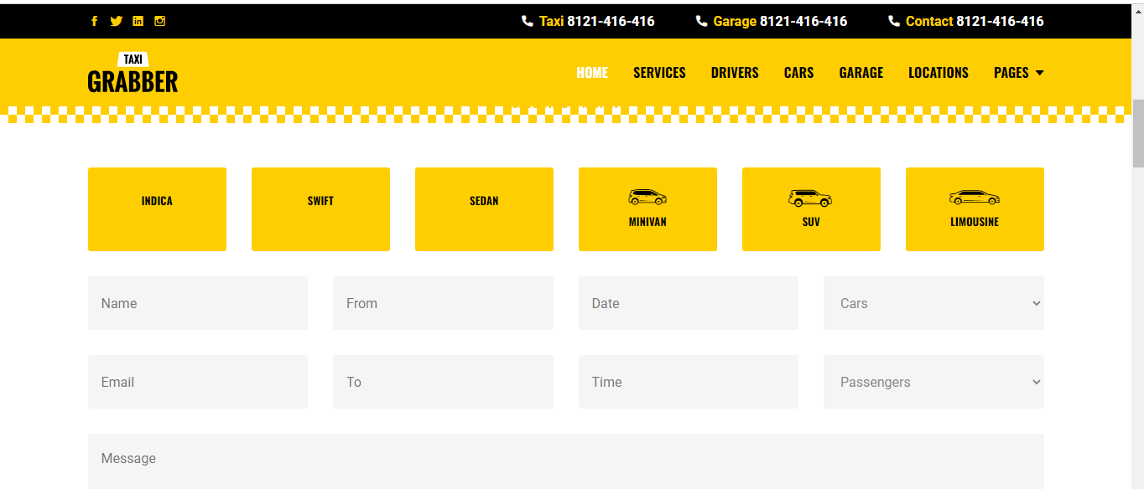

This is the final out put of different environment deploy Jenkins

Once again thank you given this golden opportunity

G. SHIVA KUMAR REDDY

115 Batch Time 9-10AM

Email:- gaddamsiva18@gmail.com